**Final Report of**

**Virtual Physical: Re-Envisioning Cardiology Care**

Submitted to Rice University

by Rachel Gu

on behalf of **Team Virtual Physical**

on April 15, 2024

**Melissa Cantú**, [mcantu@rice.edu](mailto:msc15@rice.edu), Department of Bioengineering, Rice University

**Rachel Gu**, [rag16@rice.edu](mailto:rag16@rice.edu), Department of Electrical & Computer Engineering, Rice University

**Kaiyuan (Vincent) Wu**, [kvw1@rice.edu](mailto:kvw1@rice.edu), Department of Bioengineering, Rice University

**Michelle Zheng**, [mz48@rice.edu](mailto:mz48@rice.edu), Department of Electrical & Computer Engineering, Rice University

**Table of Contents**

**Executive Summary 3**

**Introduction 4**

Understanding the Cardiology Healthcare Landscape 4

Challenges in Telecardiology 4

Limitations of Current Solutions 4

Proposed Solution: Leveraging Medical Technicians 5

Report Roadmap 5

**Design Strategy 6**

Design Specifications 6

Problem Decomposition 6

Concept Generation & Screening 9

Device Implementation Plan 12

**Final Design 14**

Virtual Physical Design Description 14

Insurance Considerations & HIPAA Compliance 22

**Testing & Results 24**

General Feature Testing 24

Data Quality Testing 25

User Experience Testing 25

**Summary & Recommendations 27**

Successful Creation of Proof-of-Concept Workflow & Web Platform for Efficient Cardiology Care 27

Recommendations for Future Improvement 27

**References 29**

**Appendix A 31**

**Appendix B 33**

**Appendix C 39**

**List of Tables**

Table 1: Abbreviations of specifications

Table 2: PCC for design criteria

**List of Figures**

Figure 1: Tytocare

Figure 2: Functional decomposition, input/output version

Figure 3: Functional decomposition, full version showing subfunctions

Figure 4: Platform Workflow

Figure 5: Login process shared by all types of users

Figure 6: Specialty Physician pages

Figure 7: Physician user interface with features

Figure 8: Medical technician pages

Figure 9: Medical Technician user interface with features

Figure 10: Mobile platform for medical technicians

Figure 11: Mobile platform user interface for medical technicians

Figure 12: Physician summary page

Figure 13: Endpoint connections to local storage in the web browser, the database, and Google API

Figure 14. UDS for Mobile Upload Process

# 

# **Executive Summary**

A critical challenge cardiology faces is the limited availability of cardiologists, with only one specialist available per 14,699 cardiology patients as of 2021 [1]. This scarcity leads to delayed diagnoses and escalates preventable complications, exacerbated by the difficulties patients face in accessing specialized care, especially in rural or underserved areas. Addressing the inefficiencies in cardiology care is vital not only to reduce the mortality associated with heart diseases but also to improve the quality of life for patients suffering from cardiovascular conditions. Streamlining the process of diagnosing and managing heart disease can lead to more timely treatments, potentially saving lives and reducing healthcare costs associated with the long-term treatment of chronic conditions.

To overcome these challenges, we developed a proof-of-concept web platform that integrates four cardiology medical tools to record physical exam data and facilitates subsequent patient-cardiologist virtual consultations, thereby providing convenient access to timely and quality cardiology healthcare, saving lives in the process. Virtual Physical’s web platform uses a JavaScript React frontend, Python Flask backend, and AWS S3 cloud storage to relay data between medical technicians and cardiologists.

Virtual Physical enables medical technicians to perform head-to-toe physical exams in a patient’s local clinic through maneuver guidance and instructions that minimize errors in physical exam data acquisition. The collected data – including text physiological measurements, auscultation audio, images, and videos – is securely stored on AWS S3. Then, the patient data can be accessed by cardiologists remotely and asynchronously. The real-time data transfer and access streamline the diagnostic process, allowing cardiologists to manage patient care more efficiently and flexibly. Beyond recording and accessing patient charts, our platform’s design includes additional functionalities such as patient data sorting, email communication directly on our website, a calendar viewer, and an integrated email-based Zoom scheduling feature, which collectively improve the overall usability and effectiveness of the website.

The choice of a hybrid telemedicine model, which relies on a local physical exam by a medical technician and a virtual consultation with a cardiologist, allows for the extension of cardiology care to a broader US population without the need for patients to travel extensively. Notably, our UDSs are created with in mind aesthetics, intuitiveness, and similarity to Epic. Furthermore, our solution leverages cloud technology, which is easily scalable and ensures data integrity and security.

Compared to traditional methods, which require in-person cardiologist visits for comprehensive evaluations, Virtual Physical is making cardiology care shorter in duration and more accessible. It represents a transformative approach to cardiology care, addressing critical gaps in the current healthcare delivery model while setting a new standard for remote cardiology services.

Recommendations for scaling this innovative solution include the integration of Amazon’s DynamoDB with the existing Amazon S3 storage, to increase the efficiency of patient data retrieval and management; additional user testing and feedback; further research into standards, regulations, and commercialization procedures for telehealth; and integration of AI to distinguish between cardiac events and anxiety-related visits, potentially transforming patient triage and outcomes in cardiology.

# **Introduction**

## Understanding the Cardiology Healthcare Landscape

Heart disease is the number one killer in the United States, responsible for 1 in 5 deaths in 2021 [2]. This pressing public health issue is exacerbated by a significant shortage of cardiologists, with only one available for every 14,699 cardiology patients [1]. This imbalance not only results in delayed diagnoses for time-sensitive treatments but also increases the likelihood of preventable complications. The root cause of this strained cardiology healthcare landscape is due to both numerical scarcity of cardiologists and high geographical distance between cardiologists and patients.

## Challenges in Telecardiology

While telemedicine has emerged as a promising solution to address the geographical gap, its application in cardiology necessitates a rethinking of traditional telemedicine. Unlike fields where subjective symptom descriptions over a video call suffice to achieve diagnosis, cardiology diagnosis relies heavily on objective physiological measurements such as blood pressure and heart sounds. Therefore, the incorporation of a comprehensive physical examination, including specialized maneuvers and essential medical tools such as ECG, digital stethoscope, sphygmomanometer, and pulse oximeter, is an unmet need for effective telecardiology.

## Limitations of Current Solutions

Tytocare has attempted to bridge this gap by incorporating general medical devices in at-home physical exams (**Figure 1**). However, Tytocare’s significant limitation is that the patients lack medical training to use these devices accurately and produce trustworthy data for cardiologists. Additionally, some patients may lack the physical dexterity required to perform certain exam maneuvers independently, highlighting the need for assistance by a second, medically-trained person.

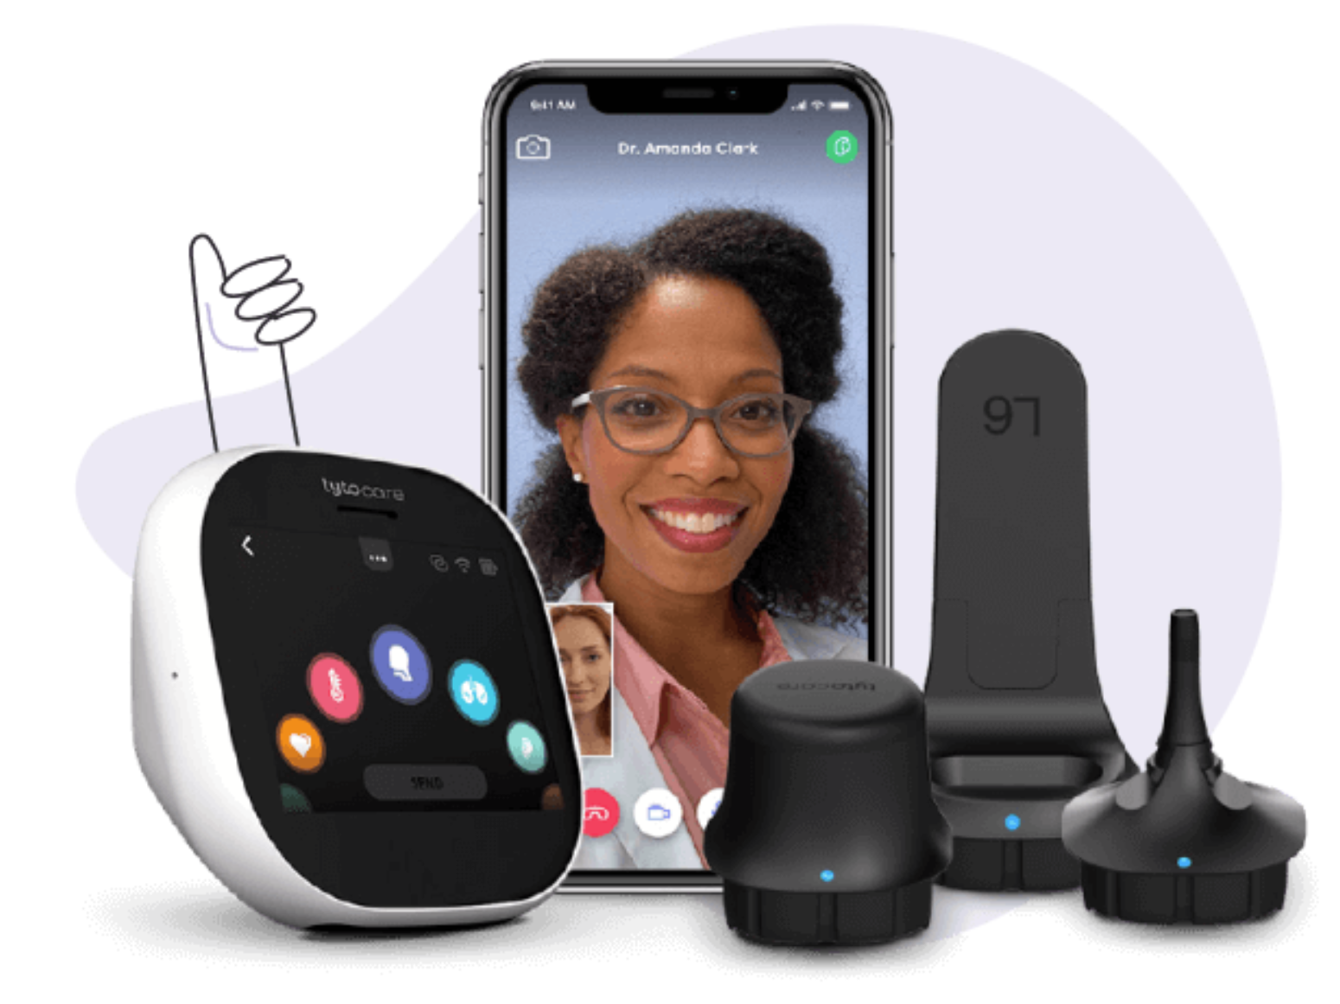

**Figure 1**. Tytocare: Tyto device shown on left, mobile app display involving virtual call with physician in middle, Tyto adaptors on right.

## Proposed Solution: Leveraging Medical Technicians

Given that the four aforementioned essential cardiology tools are not commonly available at home and require specialized training for accurate usage, an in-person component involving medically-trained professionals at local clinics becomes necessary. Thus, Virtual Physical’s novel and strategic innovation addresses this challenge by delegating cardiology-focused physical exam tasks to qualified medical technicians, including nurses, physician assistants, and nurse practitioners. This delegation not only allows cardiologists to focus their time on diagnosis rather than in-office consultations but also enhances accessibility to cardiology care for millions of patients across the United States, particularly those in rural or underserved areas.

This streamlined approach significantly expands the number of patients each cardiologist can attend to while alleviating the burden of long travel times for patients seeking specialized care. **To do this, we developed a proof-of-concept web platform that integrates 4 cardiology medical tools to record physical exam data and facilitates subsequent patient-cardiologist virtual consultations, thereby providing convenient access to *timely* and quality cardiology healthcare, saving lives in the process.**

## Report Roadmap

In the following sections, we will delve into our detailed design considerations and their implementation during the prototyping process of Virtual Physical. Furthermore, we will discuss the testing process of our platform and its results. Finally, we conclude with a summary of our device, including the potential impact of Virtual Physical on patient outcomes and the broader healthcare landscape, and our recommendations on areas for future refinement.

# 

# **Design Strategy**

## Design Specifications

Our team has been working on a comprehensive software platform tailored for cardiology, aiming to facilitate virtual physical exams seamlessly. It caters to the needs of medical professionals and patients alike, integrating with various specialized tools to capture, process, and securely store diagnostic data. Our objective is to enhance the efficiency of specialty healthcare diagnoses. Notably, our project excludes patients lacking reliable internet access and compatibility with existing electronic medical records like Epic. Detailed design specifications are outlined in Table A1.

One key specification is ensuring the stability of the website platform, with zero major glitches occurring during each physical exam session under stable WiFi conditions, aiming for less than 5 minor glitches per exam, guided by the frustration scale.

Another critical aspect is the reliable transfer and storage of data from multiple physical devices, including ECG, blood pressure cuff, pulse oximeter, digital stethoscope, video camera, and photo camera. Data integrity is paramount, with the goal of achieving 100% integrity rate during integration, validated through cross-checking between original device data quality and post-transfer quality.

Additionally, user-defined scales (UDS) will be employed, allowing medical technicians and specialty physicians to quantitatively assess the platform's intuitiveness, visual appeal, and informativeness. The usability test aims for an average score of ≥ 3 across all criteria, with an ideal score of 5.

Security measures are crucial to comply with HIPAA regulations and safeguard patient data. Password protection or two-factor authentication will restrict access to authorized personnel only. The platform will also feature robust maintenance, security updates, backup, and disaster recovery protocols.

Lastly, our platform will store data for a minimum of 10 patients via cloud storage, chosen as a proof-of-concept milestone, with the target and ideal values set accordingly.

## Problem Decomposition

Given that our system operates as a website platform, both inputs and outputs manifest as various forms of data or signals. Illustrated in **Figure 2**, the inputs can be categorized into four groups: general user input, medical technician user input, specialty physician user input, and patient user input. General user input encompasses information entered by all user types into the system.

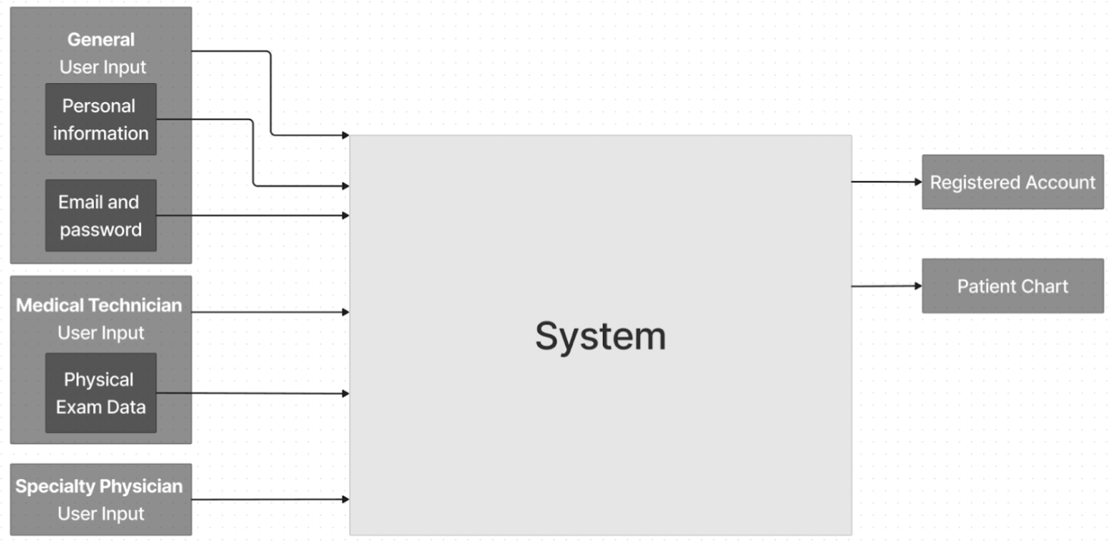**Figure 2.** Functional decomposition, input/output version. General user inputs come from all user types, while specific user type inputs refer to inputs that are only accepted when that specific user type is logged in. For example, after a patient logs in, all inputs to the system are considered patient user input until the user logs out.

Within the general user input there are two main inputs: personal information and email address and password. The inputted personal information (which will be stored in an account profile). The email (which serves as a username) and password is what all users will use to log into the platform. Entering incorrect combination of email address and password means the user will be denied access to the platform. Other general user inputs include clicking to navigate to specific pages (i.e. clicking on account creation). Specific user type inputs are unique to each user type. The medical technician user input has one main category: physical exam data. This input can be further divided into categories based on data type. There are four outputs from our system: registered accounts, patient charts, scheduled virtual calls, and after-visit summaries. Any user type can create an account and their account details (personal information as well as email and password combination) will be stored in the database along with a marker for user type. Medical technician and specialty physician users will be able to view all patient charts stored in the database.

# 

**Figure 3.** Functional decomposition, full version showing subfunctions, dashed lines represent connections made by the system while solid lines represent either inputs or outputs. An arrow pointing into the database means that data is being changed within the database (data storage) while an arrow pointing away indicates that data is being retrieved from the database (data retrieval).

As shown in **Figure 3**, general user input leads to three subfunctions: account management, account creation, and verify login. Account management has two main functions, updating personal information (such as changing password) and deleting the account. For patients, deleting their account will also provide the option of erasing their patient chart from the database. Account management involves both accessing stored data and updating data. Account creation involves two steps. First, inputting personal information (name, date of birth, home address, etc.) and second, creating a username (email address) and password. Medical technicians and specialty physicians will have an extra verification step when creating an account. This step will involve being sent an additional registration code, which can be generated by registered specialty physicians, medical technicians, and administrators. The extra verification is to help ensure patient privacy as medical technicians and specialty physicians will have complete access to all patient charts in the database. If successful, account creation will result in a registered account, the details of which will be added to the database. Lastly, verify login will ensure that the user trying to access the platform is a registered user by confirming that the email and password combination corresponds to a registered account stored in the database. This subfunction will also guide the user to separate home pages depending on the user type.

The medical technician's role encompasses three distinct subfunctions: initiating a new patient chart, providing guidance for subsequent inputs, and compiling a comprehensive physical exam record to be added to the patient chart. The initiation of new patient charts is reserved for cases where patients have not undergone any physical exams through the platform. Upon commencing a medical exam, the platform offers standards and references for accurate measurement techniques. Following this guidance, the technician inputs exam data, which is then validated based on data type and provided prompts. For instance, when recording a patient's blood pressure using a cuff, the platform ensures correct input type (numeric data) and checks if the blood pressure falls within the normal range. Inputs may vary in type, including text, audio, video, and photos, sourced from medical devices like ECGs, blood pressure cuffs, pulse oximeters, and stethoscopes. Invalid inputs prompt an error message for correction, while valid data is compiled into the physical exam record. Throughout the exam, the platform prompts the technician for necessary inputs until completion, after which the data is integrated into the patient's chart.

Both specialty physicians and medical technicians have full access to the database and can retrieve any patient chart. They can search the database by patient name, exam date, or specialty area. Specialty physicians can append comments to charts and flag them for high-risk cases, triggering a notification prompting the patient to schedule a follow-up virtual consultation at their earliest convenience. Comments are stored in the database and visible to other users. Excessively long comments prompt an error message, prompting physicians to revise them for brevity.

## Concept Generation & Screening

We initiated concept generation through a series of five brainstorming sessions, including individual, sister team, and three group sessions. The most effective brainstorming sessions involved the creation of detailed flowcharts illustrating our software, as depicted in Figures B1-B5. This approach obviated the need for morph charts and allowed us to make informed decisions regarding the intricate aspects of our platform's user inputs and interface. These decisions were directly influenced by the user needs identified during our research and informational interviews with specialty physicians and sponsors.

Subsequently, we progressed to refining and prioritizing our specifications, completing screening matrices, and outlining a clear path for prototyping beyond Cycle 1, as demonstrated in our Work Breakdown Structure (WBS) depicted in Figure B6.

Of particular significance were the decisions regarding the features of our user interfaces (UIs) for different user groups, and the protocols for storing, modifying, and retrieving patient data by physicians and medical technicians. These decisions were resolved by evaluating various brainstormed solutions against our design criteria using screening matrices. To facilitate this process, our specifications were abbreviated, as indicated in **Table 1** for clarity within the screening matrices.

**Table 1.** Abbreviations of specifications

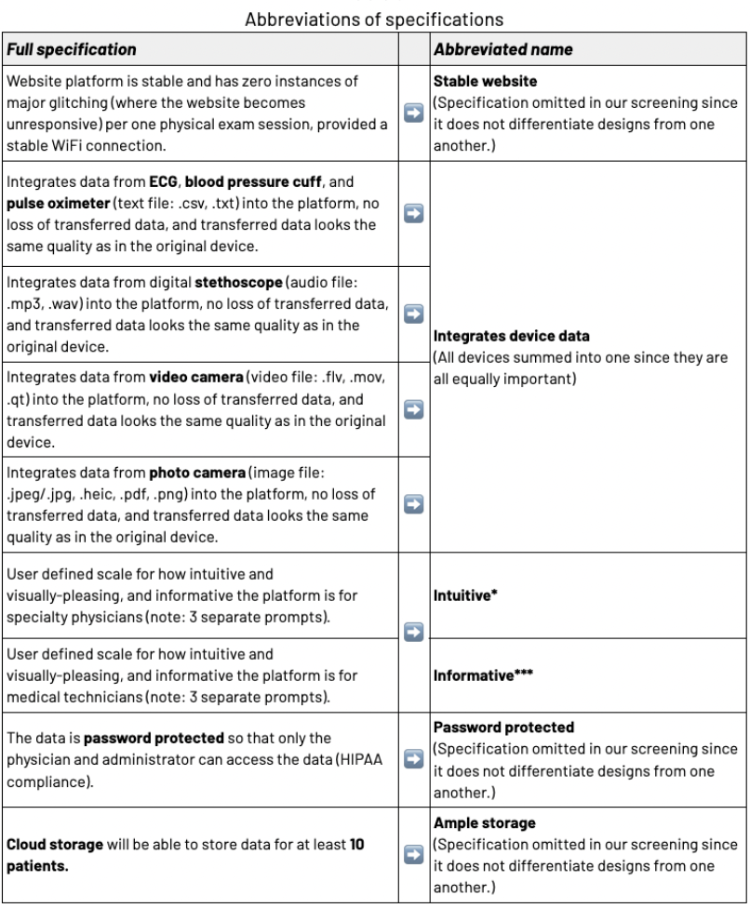

Abbreviations used in our screening and scoring matrices *,**,***: **Tables A2-A4** show the three User Defined Scales (UDS) for the intuitive, visually pleasing, and informative specification

Furthermore, the user defined scales (UDS) specifications were split into three subcategories– intuitive, visually-pleasing, and informative – since they are mutually exclusive.

Lastly, all tools used to record data in a physical exam were merged into one abbreviated criteria, since only the ability to incorporate accurate data from *all* the tools will differentiate between designs.

To more clearly define the rank of importance of each of these design criteria, the team completed a pairwise comparison chart (PCC) of our specifications as shown below in **Table 2**.

**Table 2.** PCC for design criteria

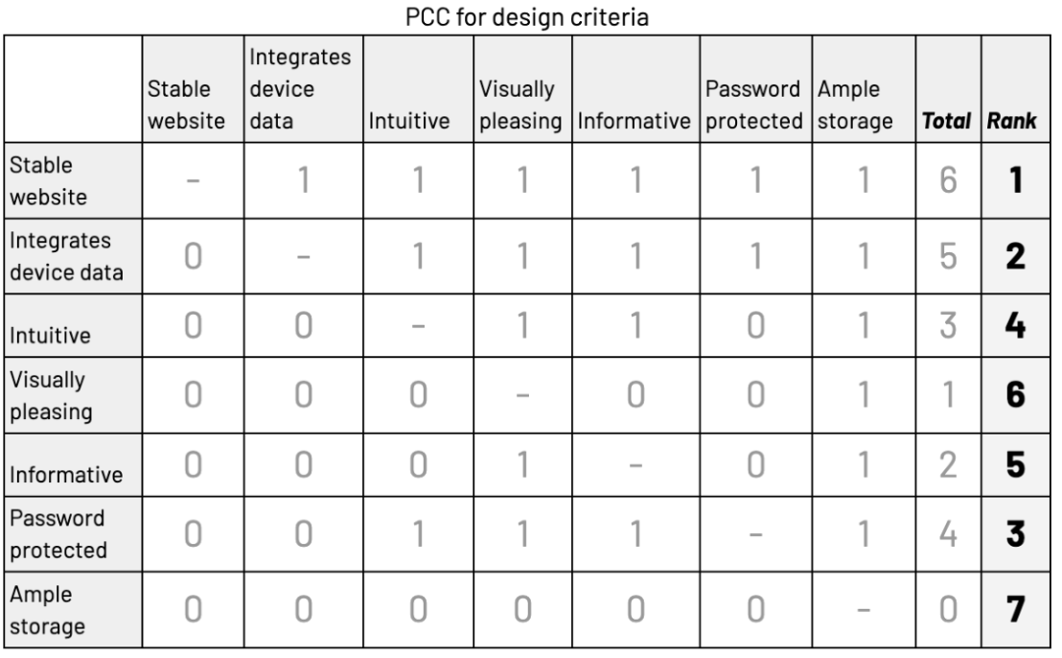

We concluded that the order of importance for our design criteria is as follows: 1. Stable website, 2. Integrates device data, 3. Password protected, 4. Intuitive, 5. Informative, 6. Visually pleasing, and 7. Ample storage.

*Stable website* is ranked first since it is a decisive factor on whether medical technicians, payers, and hospitals to which we are catering to will want to adopt our platform. If this criterion is unmet, the platform is unusable.

Similarly, our platform must integrate device data, reliably, and accurately transferring and storing data provided on the original devices. Ensuring high quality data is stored is necessary for correct diagnosis and building physician trust for our platform.

*Password protected* is ranked third, which relates to HIPAA compliance. Since the scope of our project is proof-of-concept, ensuring regulation compliance falls behind must-have features for success.

*Intuitive, informative,* and *visually pleasing* were ranked in that order since our sponsors have expressed the importance of this platform having as low a learning curve as possible. The team also believes that the patients being able to access and understand their physical exam through the Aftercare Summary provides more usability and value to our platform.

*Ample storage* comes in last again because our platform is a proof-of-concept, and the capacity of the platform to store a vast amount of patient data is not a priority within our scope.

After developing a clearer understanding of important design criteria, we began the screening process. The *patient* UI was subdivided into a virtual appointment scheduling portal and chart data display (**Tables C1 & C2**,respectively).

In **Table C1**, we narrowed down how patients are assigned doctors, the format in which virtual consults are conducted and who chooses the platform for the call, and at whose convenience the appointment is scheduled. To expedite and simplify the virtual call process, patients will be *randomly assigned a doctor* who is available to take a call with them at the *patient’s* chosen time.

In **Table C2**, we narrowed down what chart information and features the patients will see from their account and doctor-patient communication features beyond virtual consults. Educational resources on patient diagnosis may be a useful tool, but may be beyond the scope of our proof-of-concept platform.

We screened the *medical technician* UI, specifically how to input data from the medical technician’s account (**Table C3**). After screening the various designs, our team chose to move forward with the options filling the patient chart through checkboxes, the physical devices to use for data collection and the type of input data to upload being predetermined. This screening is to ensure that the data that our software platform provides is in the correct format and complies with the format of current electronic medical records (EMR) that are used by clinics and hospitals.

Next, we moved on to the *specialty* *physician* UI, and divided it into a virtual appointment scheduling portal (**Table C4**) and chart data display (**Table C5**). In **Table C4**, we removed the feature where the system automatically assigns patients to the physician, to provide specialty physicians more flexibility regarding their schedule. For **Table C5**,our team decided to remove allowing the physician to create their own chart displays which is not straightforward.

Next, we moved on to the data storage/retrieval matrix (**Table C6**). For retrieving data, our team chose to move forward using “if then” statements to detect anomalies in patient basic measurements to flag charts instead of using machine learning (ML) because that would be outside the current scope of our project. Furthermore, our team chose to use Amazon’s AWS to store data on the cloud because it is a widely used tool for web-based data storage, and it is used by our main competitor, Tytocare.

To conclude, our team screened design specifications for patient virtual appointment scheduling portal, medical technician chart, specialty physician data input UIs and data storage/retrieval. The features that we chose to move forward with ranked +2 or higher with our criteria. With our flowcharts **Figures B1-B5**, our team will efficiently implement our chosen features in our prototypes beyond Cycle 1. To arrive at the final design, we would incorporate several different facets, including user feedback, device acquisition and testing, and other aspects if necessary.

## Device Implementation Plan

We narrowed down the medical devices to use, an EKO Core digital stethoscope, Lepu Creative Medical ECG Monitor, paramed blood pressure cuff and pulse ox and purchased them. Our design specifications and objectives included integrating the data accurately from the medical devices in their appropriate format. We worked on extracting data from the digital stethoscope using the Eko app to generate a PDF of results, including a phonocardiogram and a link to listen and download the audio. To extract data from the ECG Monitor, we downloaded the ECG Viewer Manager software from Lepu Medical and generated a PDF of ECG graphs.

To integrate these results, we will add a chart feature so that the specialty physician can view the phonocardiogram images and audio from the bell and diaphragm measurements when hovering over a chest or neck diagram.

For cycle 2 objectives, we compiled a comprehensive Cardiology Physical Exam Checklist to incorporate into our workflows. We brainstormed commonalities between the medical technical and specialty physician user interfaces and how to split up the steps of the exam as tabs like the Epic software platform. We developed multiple iterations of the user interface and workflow in Figma and presented it to our sponsors for feedback such as splitting the general tab into demographic and general, for critical conditions such as observing if the patient is in severe pain. We adjusted and implemented these features into the Figma prototype and workflow. In the next cycle, we will create a mock GUI of the side-by-side chart and Zoom interface for the speciality physician.

For implementing the UI design in Figma, our team will convert the mock GUI into Javascript React code using an automated converter such as FigAct. We will implement the tab-based navigation feature for the speciality physician and medical technician into the final website code and incorporate the speciality physician integrated Zoom scheduling feature.

Our team has implemented a React app and is in the process of integrating the frontend and backend. For the frontend, we created a basic website that contains the navigation bar with a menu feature and allows for account creation, login, management, and deletion. For the backend, we worked on creating a Flask server for the website that would handle creating tokens for session login and uploading/downloading of files (supports txt, pdf, png, jpg, jpeg, gif, and wav uploads) to the local computer.

For data storage, our team will identify a suitable and subscribe to a AWS cloud-based data storage platform service. We will test if user login information and patient charts are successfully uploaded onto the cloud database. For both the medical technicians and specialty physicians accounts, we will further improve the search field so that it returns a summary of basic information of a patient when searching for first and last name. Additionally, we will incorporate extra security measures for registering an account such as sending an email with a code and completing a forgotten password page.

# 

# **Final Design**

## Virtual Physical Design Description

Virtual Physical is a robust platform HIPAA-compliant web platform designed for two main stakeholders with separate account types and user interfaces (UIs): medical technicians (MTs) and cardiologists (**Figure 4**).During a patient's physical examination at their nearest clinic, our platform facilitates the comprehensive collection and storage of medical data utilizing four essential medical devices for a cardiologist's examination: a stethoscope, ECG, sphygmomanometer, and pulse oximeter. While this data collection resembles that of established electronic medical record (EMR) systems such as Epic, our solution stands out due to its interactive guidance system. This system aids the medical technician (MT) throughout the cardiology physical exam by providing detailed step-by-step instructions and diagrams for each maneuver. This guidance ensures consistency among MTs, reduces the learning curve for platform usage, and enables any MT to effectively utilize it in a short period.

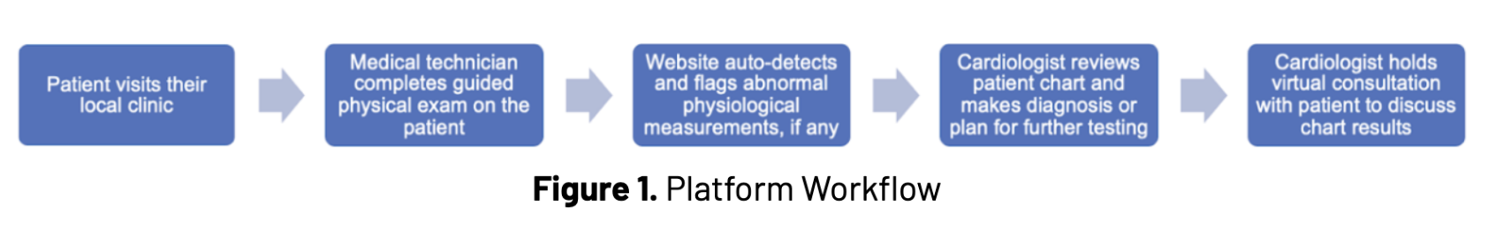

**Figure 4.** Platform Workflow

After the examination concludes, our platform compiles the input data into a succinct chart for the cardiologist's assessment. Additionally, our system automatically highlights any abnormal physiological readings, such as elevated blood pressure, displaying them prominently in red on the cardiologist's interface for easy interpretation. Our platform's primary goal is to enable cardiologists to confidently diagnose or evaluate patients remotely, eliminating the need for in-person consultations. By seamlessly integrating data from diverse medical devices into our platform in the suitable format—such as .wav files for the digital stethoscope—we ensure that cardiologists can place trust and reliance on the received data with certainty.

Virtual Physical is a reliable platform engineered to tackle the intricacies of administering physical examinations, securely storing exam data, and streamlining communication among medical technicians, specialty physicians, and patients. Comprising three primary elements - a JavaScript React frontend, a Python Flask backend, and AWS S3 cloud storage - the platform offers a cohesive solution. The frontend, developed with JavaScript React, delivers user-friendly pages, guiding medical technicians through exams, capturing pertinent patient data, and facilitating seamless interaction with the backend in real-time.

On the backend, powered by Python Flask, the platform handles the majority of internal logic and processes, including data processing, analysis, and communication with the storage infrastructure. This ensures efficient management of exam data and enables seamless integration with other components of the platform. The AWS S3 cloud storage plays a crucial role in securely storing all sensitive information related to patients and registered users. This includes patient health records, examination findings, and communication logs between medical professionals. Leveraging the scalability and reliability of AWS S3, the platform ensures data integrity and confidentiality while facilitating easy access for authorized users. Overall, Virtual Physical aims to streamline the physical examination process, enhance data management capabilities, and foster collaboration among healthcare professionals, ultimately improving patient care and outcomes.

As depicted in **Figure 5**, the login process is unified for all users. Accessing the website mandates user registration with a distinct email address, preventing multiple accounts under the same email. Users are required to create a password and select their account type, either physician or medical technician. Subsequently, administrator approval is necessary post-registration to gain website access. This additional confirmation step safeguards sensitive patient data by restricting access solely to authorized users.

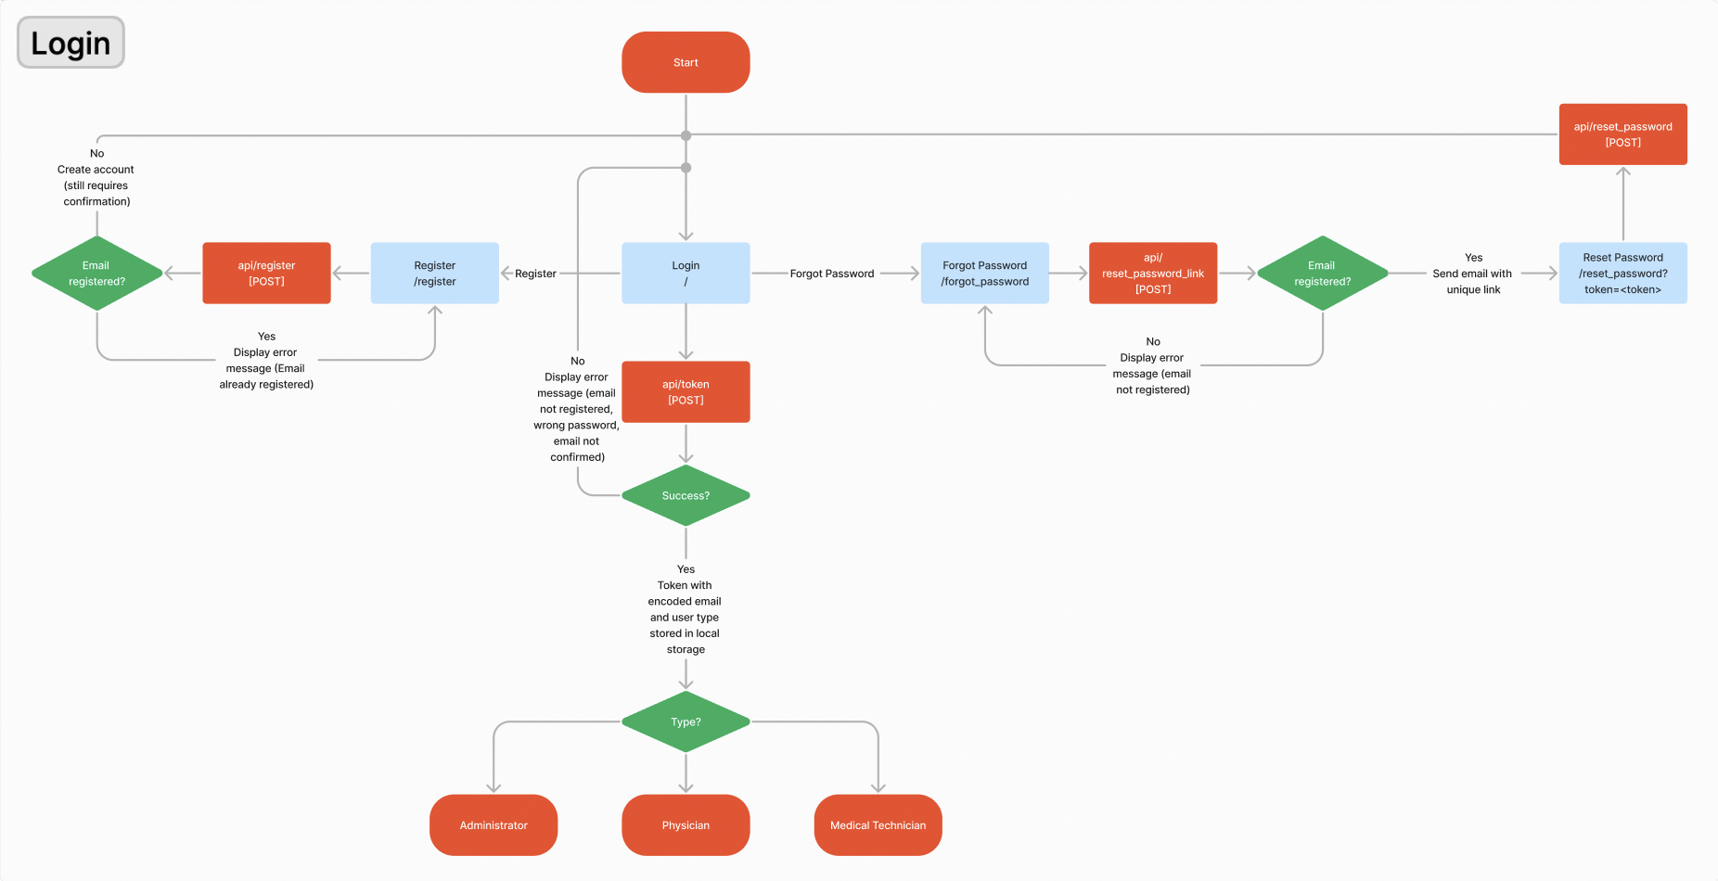

**Figure 5.** Login process shared by all types of users. There are three main functions of the login process: logging in, registering a new account, and resetting the password of an existing account. Successful login requires users to be confirmed by the administrator. After successful login, a JWT token is generated for the user and stored in local storage. Depending on the type of user, a different set of pages is rendered.

In the administrator view of the website, administrators see a list of all registered users (both confirmed and unconfirmed) and can send confirmation emails to unconfirmed users with a unique link that will confirm the account once navigated to. This confirmation process is shown. Alternatively from the login page, users can navigate to a forgotten password page where they can generate an email with a unique link to the reset password page with an encoded token. On that page, users can input a new password for their account. To login successfully, users must input the correct email and password combination and have a confirmed account.

As shown in **Figure 6**, the top navigation bar for specialty physicians provides access to four different pages: patient search, messages, calendar, and user settings. The messages page loads a list of all patient emails and allows physicians to easily write emails (sent from the website email [virtualphysical23@gmail.com](mailto:virtualphysical23@gmail.com)) to any patient. The calendar tab relies on Google Calendar API to show all appointments for each physician.

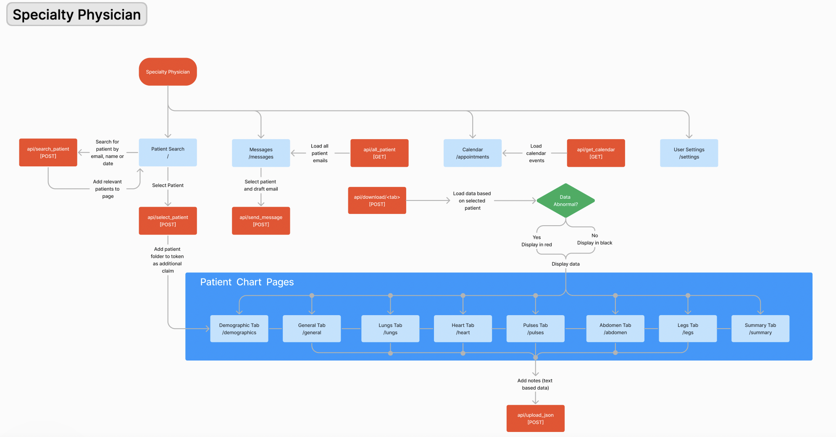

**Figure 6.** Specialty Physician pages: four main functionalities, viewing patient charts, sending messages (emails) to patients, viewing calendar appointments, and user settings. To view a patient chart, physicians first select a patient through the patient search page. Once a patient is selected, the physician is directed to the patient chart pages. All tabs within the patient chart page can be navigated to from any other tab.

As shown in **Figure 7**, the top navigation bar for specialty physicians provides access to four different pages: patient search, messages, calendar, and user settings. The messages page loads a list of all patient emails and allows physicians to easily write emails (sent from the website email [virtualphysical23@gmail.com](mailto:virtualphysical23@gmail.com)) to any patient. The calendar tab relies on Google Calendar API to show all appointments for each physician.

From the patient search page, physicians can search through stored physical exams by patient name, email, or the date of the exam. Upon search, the page will be populated with a table of relevant stored exams. Physicians can then select which patient chart to view. The unique combination of email, name, and date form the folder in which data about that particular physical exam can be found. This combination is added as an additional claim in the original JWT login token stored in local storage.

After selecting a patient chart to view, physicians are directed to the patient chart pages. There are 8 tabs in this section: demographic, general, lungs, pulses, heart, abdomen, legs, and summary. These tabs can be freely navigated to by means of a tab navigation component which contains all of the necessary links. Data is retrieved from the appropriate folder as designated by the stored access token. Prior to rendering the data on the page, the react frontend checks for any abnormal or concerning metrics and displays all abnormalities in red to bring the physician’s attention to them. Physicians can also add notes to sections of the physical exam which will be stored in S3.

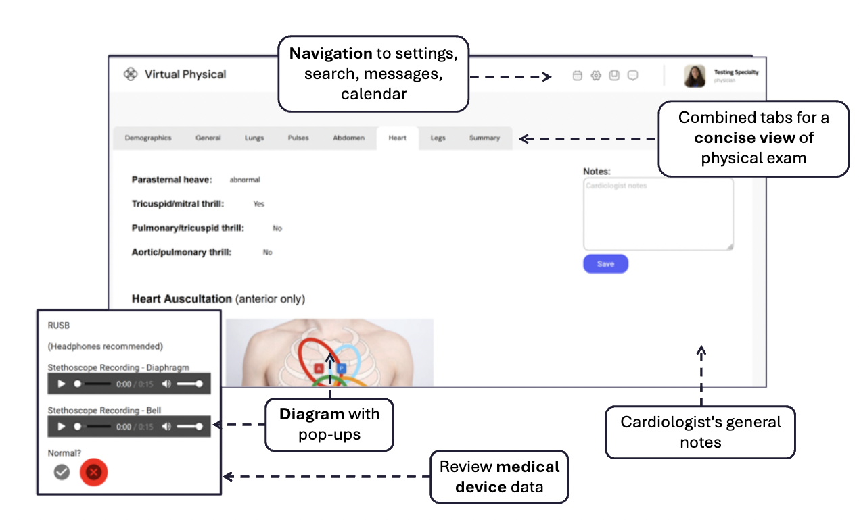

**Figure 7.** Physician user interface with features such as navigation to settings, search, messages, calendar, diagram with pop-ups and general notes

Physicians have a unique tab compared to the medical technicians, the summary tab. This tab summarizes all information from the physical exam and includes the physician’s notes. It provides a quick overview of the physical exam. To select a different patient chart, physicians can navigate back to the patient search page and select a new patient to view. Patient charts can only be viewed one at a time unless physicians log into the website from another browser/platform.

Acknowledging that medical technicians may lack the extensive experience of cardiologists in conducting such exams, our platform includes a guidance component that enhances consistency and accuracy across different medical technicians shown in **Figure 9**. Additionally, given that patients in rural and underserved areas may not have access to a large pool of medically trained professionals and clinics, our software platform aims to provide sufficient guidance for any medical technician to perform a thorough cardiology physical exam from head to toe, irrespective of their background and training. With the guidance component ensuring consistency and accuracy across various medical technicians, specialty physicians can have greater confidence in the information provided, leading to more precise diagnoses and tailored treatment plans.

As shown in **Figure 8**, the top navigation bar for medical technicians only navigates to two pages: create patient chart and user settings. To create a patient chart, medical technicians must input the name and email of the patient. A folder name is generated using the patient name, email, and the current date. This folder refers to the location in S3 where the physical exam data will be stored. This folder is added to the token stored in local storage.

In the patient chart pages, there are two main types of files to be uploaded, either json files or any other type of file (pdf, wav, jpeg, mp4). The json files are dictionaries, mapping keys to values and include both text data and any numerical metrics. These dictionaries cannot be uploaded from the mobile platform. For other files, the user can choose to upload it either from mobile platform (after logging in on mobile) or from the laptop platform. For both platforms, the file type is checked depending on the file prompt, if the file is of the correct type then the file is sent to S3 to be stored in the appropriate patient folder. The validity of all medical technician inputs is checked as shown. If the input is not valid, the medical technician will be shown an error prompt.

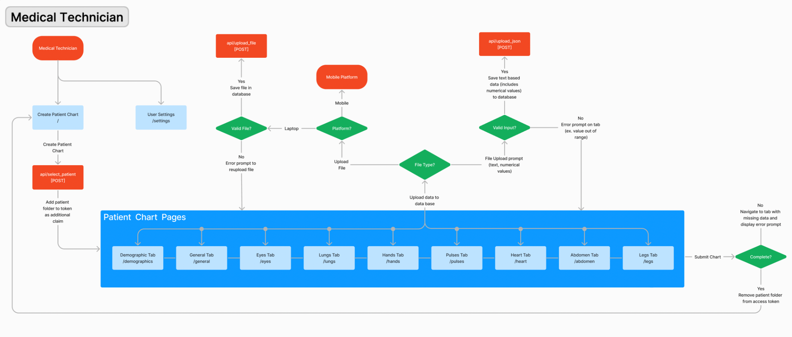

**Figure 8.** Medical technician pages: two main functionalities, creating patient chart and user settings. Upon creating a patient chart, medical technicians will gain access to the patient chart pages where they are guided through the process of taking a physical exam. For file inputs, medical technicians can choose to use the mobile platform to upload files or to take photos/videos.

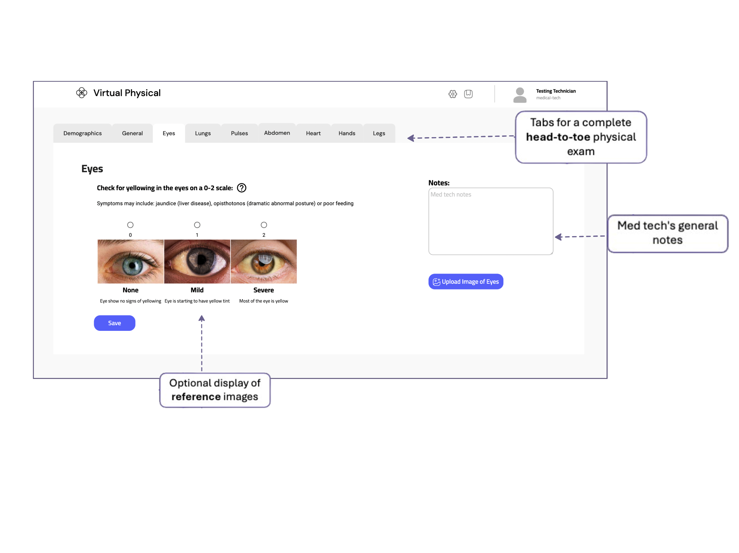

**Figure 9**. Medical Technician user interface with features such as optional display of reference images and general notes.

Medical technicians can also utilize the website on their mobile devices, as depicted in **Figure 10.** To access the mobile interface, they need to first log in to the website. Once logged in successfully, they will be directed to a mobile prompt page containing a table of prompts for file uploads. Each prompt facilitates file upload and necessitates verifying the correct file type based on the prompt. In cases where the prompt requires an image or video, medical technicians have the option to capture a photo or video directly from the webpage. These prompts are segregated into individual pages. Upon capturing the image/video, it is promptly displayed on the webpage, allowing the medical technician to assess its quality and decide whether to upload it to the patient chart or retake it. The list of file prompts on the mobile prompt page updates automatically to reflect the files already uploaded.

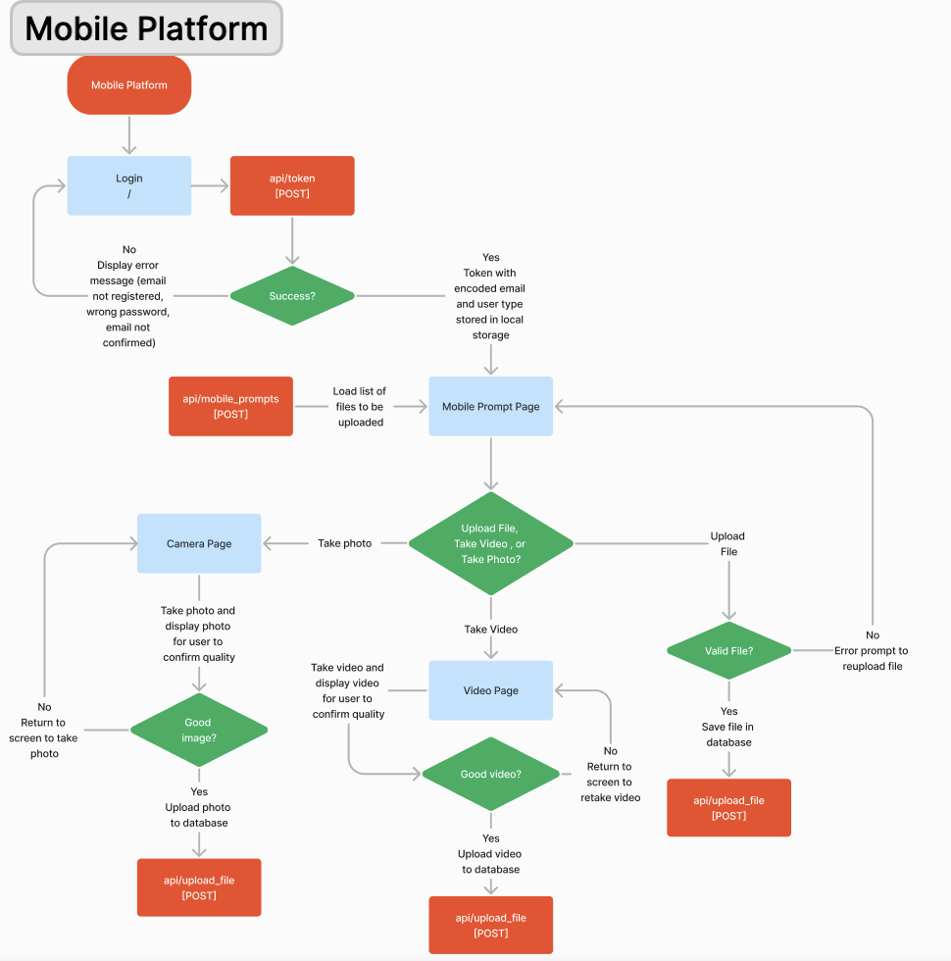

**Figure 10**. Mobile platform for medical technicians: after logging in, medical technicians can view a page of prompts for file uploads. They can either upload a file, or depending on the file type take a photo or video with their phone camera using an interface directly in the web browser. Using this method sends the photos/videos directly to the database.

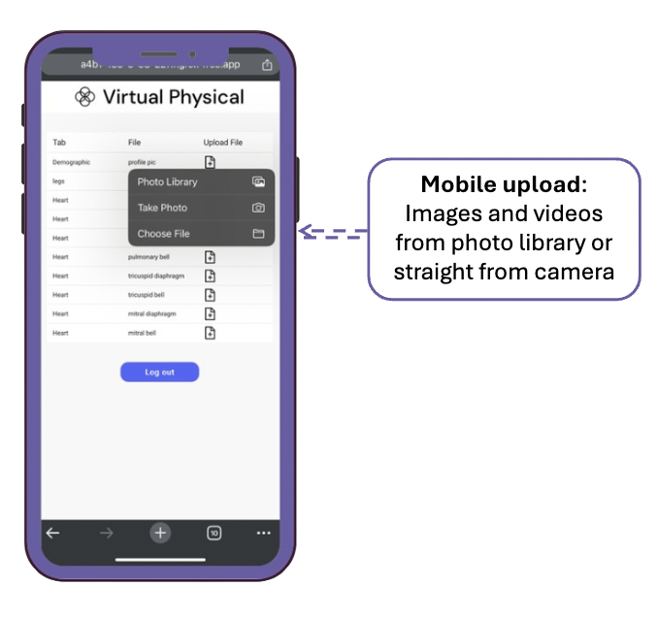

**Figure 11**. Mobile platform user interface for medical technicians showing the process of uploading images and videos directly from photo library or camera

After concluding the physical examination, medical technicians proceed to submit the chart. During the submission process, every entry in each tab must contain some form of response—either the actual data or a notation indicating a skipped section—prior to submission. If any section is incomplete, the medical technician will be redirected to the specific tab lacking input. User input on the React frontend triggers requests to the Flask backend. This Flask backend comprises a series of API endpoints primarily tasked with retrieving and storing data in the S3 database. Additionally, it interfaces with the Google API for functions such as email transmission and calendar event viewing. Many of these API endpoints necessitate JWT token authentication, ensuring usage only when users are logged in. To facilitate this, the JWT token is stored in the browser's local storage. The cardiologist will be able to view all the input data and notes in the summary page or close inspection.

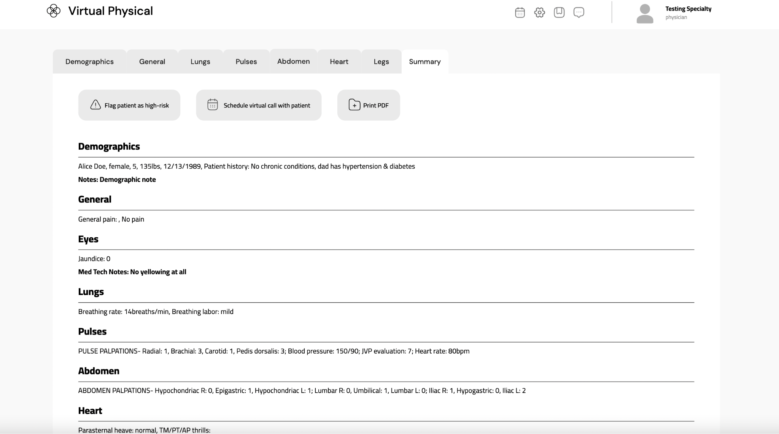

**Figure 12**. Physician summary page where they can view all information from the head to toe physical exam uploaded from the medical technician

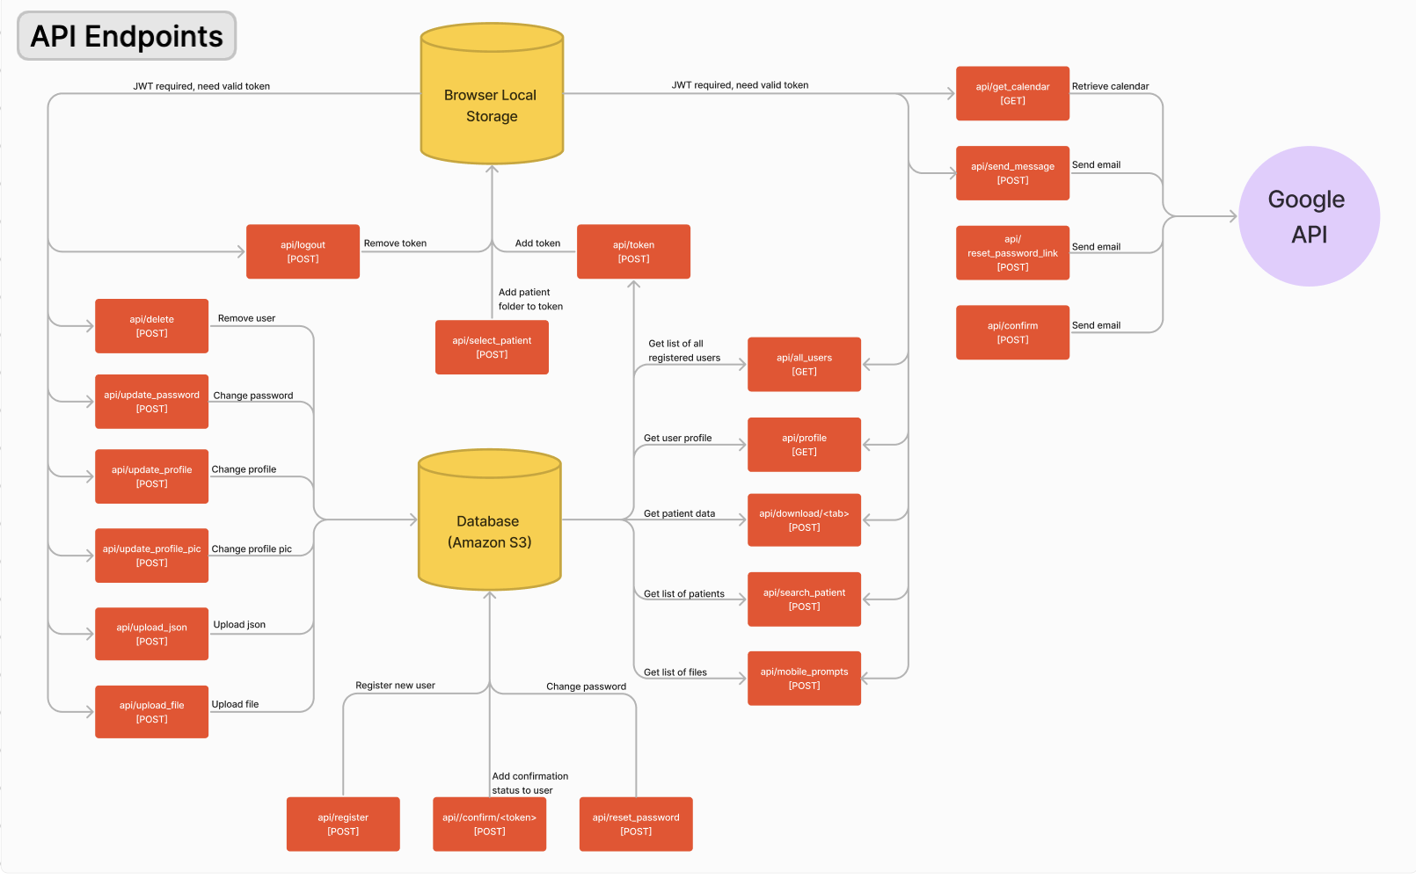

**Figure 13.** Endpoint connections to local storage in the web browser, the database, and Google API (Gmail API to send emails and Google Calendar API to get calendar events). Arrows pointing into local storage and/or database indicate that data is being stored or changed. Arrows pointing out of local storage and/or database indicate data being retrieved. The browser local storage is primarily used to store the JWT access token.

## Insurance Considerations & HIPAA Compliance

While our scope and focus has primarily been on developing a solution to improve cardiology healthcare accessibility and efficiency, we recognize the importance of aligning our efforts with existing healthcare frameworks, including insurance reimbursement policies. Understanding the financial implications of our proposed solution is essential for its sustainability and widespread adoption. Therefore, we conducted foundational research on private insurers to assess the potential for patient reimbursement and ensure the viability of our product within the current healthcare reimbursement landscape.

As expanded by the U.S. Centers for Medicare & Medicaid Services (CMS) or through the Consolidated Appropriations Act (CAA) of 2023 [3], CMS will provide reimbursement for many telehealth services with Current Procedural Terminology (CPT) codes. Depending on the purpose of the exam (new patient or established patient) and the extent of services provided, our product would fall under multiple CPT codes, which would determine the amount of reimbursement. Our product would fall under Evaluation and Management (E/M) codes which range from 992020 to 99499 [4]. Furthermore, many private insurances cover telehealth services [5].

Moreover, as we strive to improve cardiology accessibility through our innovative telehealth solution, we must also prioritize the protection of patient privacy and security. Compliance with the Health Insurance Portability and Accountability Act of 1996 (HIPAA) is non-negotiable in our design considerations [6] [7]. HIPAA sets standards for the privacy and security of electronic healthcare data, ensuring that patient information remains confidential and protected against unauthorized access or disclosure [7].

To abide by HIPAA, our design considerations included the following: Firstly, the team selected the Amazon S3 by AWS cloud storage option to provide personal health information (PHI) encryption at rest and in transit (since we must use HTTPS endpoints that accept encrypted transport for S3) [8]. AWS also inherently offers a variety of disaster recovery mechanisms which are required for HIPAA compliance [9]. Secondly, we deployed our website to a Squarespace public domain to ensure a secure connection (HTTPS) and so that users can connect to our website from various locations. Finally, our proof-of-concept prototype workflow includes conducting patient-cardiologist consultations through Zoom for Healthcare, which provides end-to-end encryption [10].

By addressing these critical aspects of insurance coverage and HIPAA compliance, we ensure that our innovative solution not only meets the needs of healthcare providers but also aligns with regulatory requirements and industry standards.

# 

# **Testing & Results**

There were three main areas of testing regarding our project. First, tests regarding general features of the website, such as the capability to run through a complete physical exam on both the medical technician and cardiologist sides, the security of the website (patient information can only be accessed by authorized users), and the capacity to store at least 10 complete patient charts in Amazon S3. The second set of tests are regarding the quality of data stored in S3. They are centered on ensuring the quality of the data upon upload is maintained during storage and subsequent redownload into the website. The last set of tests are regarding user feedback, surveying medical technicians and cardiologists using user defined scales on how intuitive, visually pleasing, and informative the website as well as the similarity to Epic.

## General Feature Testing

To ensure the general workability of the website, all pages on the medical technician and cardiologist sides of the website need to be tested. Since the website relies heavily on a stable WiFI connection, especially on the cardiologist side when fetching data from amazon S3. This test involves a complete walkthrough of all of the pages of the website with a stable WiFi connection with the tester indicating if the website ever becomes completely unresponsive or has a major glitch. 5 students, excluding team members, will be recruited to complete this walkthrough. By recruiting testers who are unfamiliar with the website, we ensure that the website is functional for the average user who has never seen the platform before.

The walkthrough will involve the tester first creating a new account, logging in, updating their password in the user settings page, and resetting their password through the forgot password page. For the medical technician pages, testers are expected to create a new patient chart and completely fill out every tab. Since this test is geared towards the average user, no additional guidance besides what is provided on the medical technician pages will be provided to testers. Once they have completed the patient chart, testers will log out and log in as a cardiologist then search for and view the chart they have just added. Additionally, testers will be asked to save at least one note in the cardiologist pages and send a scheduling email to the fake patient.

The purpose of the next test is to ensure that the data is password protected, a key component in ensuring HIPAA compliance. Patient information should only be accessible by authorized users, and should not be able to be accessed without the proper credentials. There are two main sides to test the security of the website, on the front end and on the back end. For the front end testing, team members will navigate to urls corresponding to where patient data would be if properly logged in (the cardiologist pages, as well as the messages page). To ensure that json web tokens (which are being used as credentials for login sessions) expire properly when the user logs out, a team member will log into an account, copy the JWT token stored in local storage of the browser then log out. After logging out, the team member will add the token into local storage to ensure that the patient data will not be loaded into the pages.

For the backend tests, GET requests will be sent to the /download API endpoints without the proper authorization tokens or with the previously expired token to ensure that data cannot be fetched from Amazon S3 without proper credentials.

Amazon S3 should be able to store the data for at least 10 patients. It needs to store the data for complete virtual physical exams, including demographics, general conditions, and comprehensive observations and file uploads for a full head to toe exam as guided by the medical technician webpages. Since Amazon S3 allows for unlimited total volume of data to be uploaded (more storage can be purchased depending on the volume), the sum of the 10 charts’ file sizes does not surpass the maximum capacity. The main limitation of Amazon S3 is that each individual file uploaded must not exceed 5TB.

## Data Quality Testing

An important feature of the website is the capability to upload and load different file types to support different files from medical devices. First, the website should integrate data from the digital stethoscope, which comes in the form of .wav files from the Eko digital stethoscope. There are 11 audio files from the digital stethoscope uploaded into the website: 4 heart regions, 1 carotid artery, and 6 lung regions. A team member will download data directly from the EKO website then use GET requests with authorized credentials to download data from S3 (since data cannot be downloaded directly from the website). An audio comparison tool on the Blue2Digital website will be used to compare the matching 11 sample pairs from EKO and from the website. Each audio file must receive a score of at least 95% similarity for the quality of the data to be sufficiently preserved.

For data from a video camera (.mov), a team member will ensure that 2 videos are saved directly from a phone camera and the data downloaded from Amazon S3 (after uploading the previous video) is the same. For the comparison of the videos, Apple’s AVQT score. A score of at least 4.5 will indicate that the video quality was preserved.

Lastly, data from the ECG and phone camera (.jpeg/.jpg, and .png) should be preserved through upload and subsequent download. A team member will ensure 1 ECG image and 3 images taken directly from the phone camera are saved and these files are uploaded using the website and then fetched from Amazon S3. To compare the quality of these images, the Img2Go website will be used to provide accurate identification of even the slightest differences between the images. Setting the method to AE, color to red, and threshold to 50, the percentage difference will be calculated for each pair of sample images. The percentage difference for each image should be no higher than 5%.

## User Experience Testing

Another major component of our project is the user experience. We developed the user interface for both the medical technician and the cardiologist by engaging in active communication with the relative users. For example, we initially included a calendar feature for the cardiologist but after conferring with both faculty and cardiologists realized that this feature would not be used often by cardiologists and thus put more of an emphasis on developing other features of the website, like the capability to send automatically generated emails with an embedded link for patients to schedule an appointment with cardiologists.

For user feedback, we focused primarily on three main scales for how intuitive, visually-pleasing, and informative the platform is. See table A2, A3, and A4 for the specific details on the 1-5 user defined scales. We also surveyed medical technicians and cardiologists on how similar to Epic they found the platform (as a similarity to Epic would decrease the learning curve necessary for proper use of the website). We used Epic as a model for the general mental map of the website. These surveys were sent to medical technicians and cardiologists.

Thus far, only one medical technician responded to our requests for feedback. They rated our platform with a 3 for intuitive, 4 for visually-pleasing, and a 4 for informative. In particular, they commented that they “liked that [we] included pictures for reference and think that is enough [guidance]”. For additional features they would like added to the website, they mentioned “adding checkpoint/alerts if something was entered incorrectly or might be out of range” and “checkpoint for attachments.. to make sure the picture quality or the audio quality is acceptable”. These features have been incorporated into the current website, but we have yet to complete further user testing.

We also surveyed medical technicians on how streamlined the mobile upload process is with a user defined scale from 1-5 (1 being extremely tedious, requiring extensive effort and 5 being easy and simple process, requiring minimal effort). The medical technician commented that the process is “self explanatory" and anyone who is on the website for the first time should be able to attach the files according to the description (demographics, legs, etc.). We plan on surveying more medical technicians on the mobile upload.

**Figure 14.** UDS for Mobile Upload Process

| Score | 1 | 2 | 3 | 4 | 5 |
| --- | --- | --- | --- | --- | --- |
| Meaning | extremely tedious process, requiring extensive effort | moderately tedious process, requiring substantial effort | average process, requiring moderate effort | relatively simple process, requiring modest effort | easy and simple process, requiring minimal effort |

For the cardiologist response we had responses from one cardiologist and an IT manager, who both rated the platform with 4s across all scales including with similarity to Epic. The cardiologist mentioned that they “liked the lung/heart displays and especially the format in which the audio sounds are clickable”. While the IT manager pointed out the potential issues in having a monthly calendar view and suggested incorporating “text messaging in addition to email”.

# **Summary & Recommendations**

## Successful Creation of Proof-of-Concept Workflow & Web Platform for Efficient Cardiology Care

With the goal of revolutionizing cardiology healthcare accessibility and efficiency, our team developed Virtual Physical, a robust web platform tailored for the unique user needs of medical technicians and cardiologists. Guided by HIPAA compliance and user-centered design, our project integrates data from 4 medical devices foundational to cardiology, provides guidance for medical technicians completing a comprehensive cardiology physical exam, and enables remote patient evaluations by cardiologists.

Our design strategy prioritized user feedback and adherence to healthcare regulations. While out of our scope, we still recognized the importance of aligning our efforts with existing healthcare frameworks, such as insurance reimbursement policies.

The final design of Virtual Physical encompasses a JavaScript React frontend, a Python Flask backend, and AWS S3 cloud storage, offering a cohesive solution for seamless interaction and data management. For medical technicians, the platform features step-by-step guidance through physical examinations, facilitating data collection and storage for cardiologists' assessment. Meanwhile, cardiologists benefit from a streamlined interface for patient chart review, message communication, and appointment scheduling, tailored to their specific needs.

Testing and results validation are integral to ensuring the functionality, security, and user experience of Virtual Physical. General feature testing involves walkthroughs by five testers, evaluating usability and responsiveness across all platform functionalities. Security tests confirm data access restrictions, while Amazon S3 storage capacity tests ensure scalability and reliability.

Data quality testing focuses on preserving the integrity of uploaded files, including audio, video, and image formats. Specialized tools are employed to compare pre- and post-storage data, confirming minimal quality loss.

User experience testing encompasses user surveys to gauge intuitiveness, visual appeal, and informativeness of the platform. Initial feedback from medical technicians and cardiologists highlighted positive ratings and valuable suggestions for improvement, such as implementing data quality checkpoints and incorporating text messaging for patient-cardiologist communication.

In summary, Virtual Physical represents a transformative solution in cardiology healthcare, driven by a user-centered design approach and close adherence to regulatory standards. As we continue to iterate and refine Virtual Physical based on user insights, we remain committed to our mission of making specialty healthcare accessible for all.

## Recommendations for Future Improvement

After completion of a proof-of-concept prototype, the team has identified a few areas for future improvement as the device is further refined.

When considering efficient scaling of our project to larger clinics with hundreds of patients, our web platform’s patient data search efficiency would be greatly bolstered by adding Amazon’s DynamoDB service in addition to Amazon S3, which we currently use to store our patient data on the cloud. DynamoDB’s addition would have allowed us to map objects in S3 to the person they belong to, decreasing search time when loading a patient chart [11]. This would particularly be beneficial for patients that have multiple physical exam charts performed on different dates.

One of our greatest challenges throughout the development of Virtual Physical was getting busy medical technicians and cardiologists to provide feedback on our prototypes. In the future, we recommend compiling a long list of possible medical technicians and cardiologists, formed after consulting with various Rice faculty with connections to doctors in the Texas Medical Center, to interview throughout the project’s progression. Further testing and refinement with more of these contacts is a crucial next step.

While this platform was developed with the Kelsey Seybold Clinic in Houston, Texas in mind, further work in commercialization of the platform, confirmation of our platform’s adherence to regulations and standards, and marketing would be required before broader implementation. Our sponsors suggested integrating text messaging in addition to email messaging with patients as a way to imitate Epic, a popular EMR used by Kelsey Seybold and many other hospitals across the US. On this note, another important feature that could be its own project is the integration of data acquired during Virtual Physical’s workflow to nationwide electronic health record (EHR) systems so that patient health records can be accessed by a vast network of clinics across the US, not only cardiologists registered in our website.

After a year of extensive conversations with our project sponsor, a cardiologist at the Kelsey Seybold Clinic, and thorough research into the cardiology healthcare landscape, we uncovered a prevalent issue: a significant number of patients visit the emergency room or cardiologists' offices under the impression of having a heart condition when, in fact, they are experiencing severe anxiety. This phenomenon has been recognized and over-applied by medical professionals, leading to instances where patients with genuine heart conditions are mistakenly dismissed as suffering from anxiety [12, 13]. Incorporating artificial intelligence (AI) into our website to differentiate between patients experiencing genuine heart issues and those grappling with anxiety would represent an original and impactful advancement relative to competitors. By accurately identifying and directing patients with real heart conditions to cardiologists, this AI integration could revolutionize the diagnosis process and significantly improve patient outcomes. Thorough research into the standards and regulations governing the ethical use of AI in healthcare would have to be conducted prior to starting this project. Furthermore, obtaining training datasets from people of diverse ethnic backgrounds is essential to ensure the development of an ethically sound and broadly effective AI. This would be an excellent senior design project for computer science students or any student interested in practicing machine learning skills in the future.

# 

# **References**

[1] “Heart Disease Facts.” Centers for Disease Control and Prevention, Centers for Disease Control and Prevention, 15 May 2023, www.cdc.gov/heartdisease/facts.htm.

[2] “Number of People per Active Physician by Specialty, 2021.” AAMC, Association of American Medical Colleges, 31 Dec. 2021, www.aamc.org/data-reports/workforce/data/number-people-active-physician-specialty-2021.

[3] “AMA telehealth policy, coding & payment,” American Medical Association, Jul. 19, 2023. https://www.ama-assn.org/practice-management/digital/ama-telehealth-policy-coding-payment (accessed Sep. 21, 2023).

[4] “Private insurance coverage for telehealth | Telehealth.HHS.gov.” https://telehealth.hhs.gov/providers/billing-and-reimbursement/private-insurance-coverage-for-telehealth (accessed Sep. 21, 2023).

[5] “Evaluation and Management (E/M) Coding,” American Medical Association, Sep. 06, 2023. https://www.ama-assn.org/topics/evaluation-and-management-em-coding (accessed Sep. 21, 2023).

[6] Office for Civil Rights (OCR), “What is telehealth?,” HHS.gov, Mar. 27, 2020. https://www.hhs.gov/hipaa/for-professionals/faq/3015/what-is-telehealth/index.html (accessed Sep. 21, 2023).

[7] Office for Civil Rights (OCR), “HIPAA for Professionals,” HHS.gov, Sep. 10, 2015. https://www.hhs.gov/hipaa/for-professionals/index.html (accessed Sep. 21, 2023).

[8] HIPAA compliance - amazon web services (AWS). (n.d.-b). https://aws.amazon.com/compliance/hipaa-compliance/

[9] Architecting for HIPAA security and compliance on Amazon Web Services - architecting for HIPAA security and compliance on Amazon Web Services. (n.d.-a). https://docs.aws.amazon.com/whitepapers/latest/architecting-hipaa-security-and-compliance-on-aws/architecting-hipaa-security-and-compliance-on-aws.html

[10] “Telehealth for Providers: What You Need to Know.” U.S. Department of Health and Human Services, May 2023. [Online]. Available: https://www.cms.gov/files/document/telehealth-toolkit-providers.pd

[11] Fast nosql key-value database – amazon dynamodb – amazon web services. (n.d.). https://aws.amazon.com/dynamodb/

[12] Heart and Stroke Foundation of Canada. (n.d.). *Karen’s story: “They told me it was anxiety.”* Heart and Stroke Foundation of Canada. https://www.heartandstroke.ca/articles/heart-disease-in-women-they-told-me-it-was-anxiety

[13] Mastroianni, B. (2023, December 1). *Doctors misdiagnosed her genetic heart condition as anxiety for years*. Healthline. https://www.healthline.com/health-news/hypertrophich-cardiomyopathy-misdiagnosed-anxiety

# **Appendix A**

Design Specifications

**Table A1**

Project Specifications with Target and Ideal Values

|  | Specification #1 | Specification #2 | Specification #3 | Specification #4 | Specification #5 | Specification #6 | Specification #7 | Specification #8 | Specification #9 |
| --- | --- | --- | --- | --- | --- | --- | --- | --- | --- |
|  | Website platform is stable and has zero instances of major glitching (where website becomes unresponsive) per one physical exam session, provided a stable WiFi connection. | Integrates data from **ECG**, **blood pressure cuff**, and **pulse oximeter** (text file: .csv, .txt) into the platform, no loss of transferred data, and transferred data looks the same quality as in the original device. | Integrates data from digital **stethoscope** (audio file: .mp3, .wav) into the platform, no loss of transferred data, and transferred data looks the same quality as in the original device. | Integrates data from **video camera** (video file: .flv, .mov, .qt) into the platform, no loss of transferred data, and transferred data looks the same quality as in the original device. | Integrates data from **photo camera** (image file: .jpeg/.jpg, .heic, .pdf, .png) into the platform, no loss of transferred data, and transferred data looks the same quality as in the original device. | User defined scale for how intuitive*, visually-pleasing**, and informative*** platform is for **specialty physician** (note: 3 separate prompts). | User defined scale for how intuitive*, visually-pleasing**, and informative*** platform is for **medical technicians** (note: 3 separate prompts). | The data is **password protected** so that only the physician and administrator can access the data. | **Cloud storage** will be able to store data for at least **10** patients. |
| Target Value | ≤ 5 minor glitches & 0 major glitches per exam | yes | yes | yes | yes | average of 3 | average of 3 | yes | yes |
| Ideal Value | 0 glitches per exam | yes | yes | yes | yes | average of 5 | average of 5 | yes | yes |

**Table A2**

UDS for “Intuitive” specification

| 1 | 2 | 3 | 4 | 5 |
| --- | --- | --- | --- | --- |
| Platform is completely unintuitive. A training course/manual on how to use the platform alone would not resolve the learning curve to learn within a week | Platform is leaning towards unintuitive, but a training course/manual on how to use the platform would help to learn within days | Platform has a learning curve, but is intuitive enough to learn without training/a manual within a day | Platform is leaning towards intuitiveness, and is learnable within hours | Platform is completely intuitive and has no learning curve. Fully usable immediately |

**Table A3**

UDS for “Visually pleasing” specification

| 1 | 2 | 3 | 4 | 5 |
| --- | --- | --- | --- | --- |
| Platform is wholly visually displeasing, enough to alone steer user away from using the platform | Platform is generally visually displeasing | Platform is neutral in aesthetics-- it is neither visually pleasing or displeasing | Platform is generally visually pleasing | Platform is fully visually pleasing website, enough to alone draw user into using the platform |

**Table A4**

UDS for “Informative” specification

| 1 | 2 | 3 | 4 | 5 |
| --- | --- | --- | --- | --- |
| Platform does not convey anything of value to the user (0 takeaways per page) | Platform conveys *minimal/not enough* valuable information to user (1 takeaway per page) | Platform conveys an unremarkable amount of valuable information to user (2-4 takeaways per page) | Platform conveys a satisfactory amount of valuable information to user (5-8 takeaways per page) | Platform conveys an excellent amount of valuable information to user (9+ takeaways per page) |

# **Appendix B**

Brainstorming & WBS

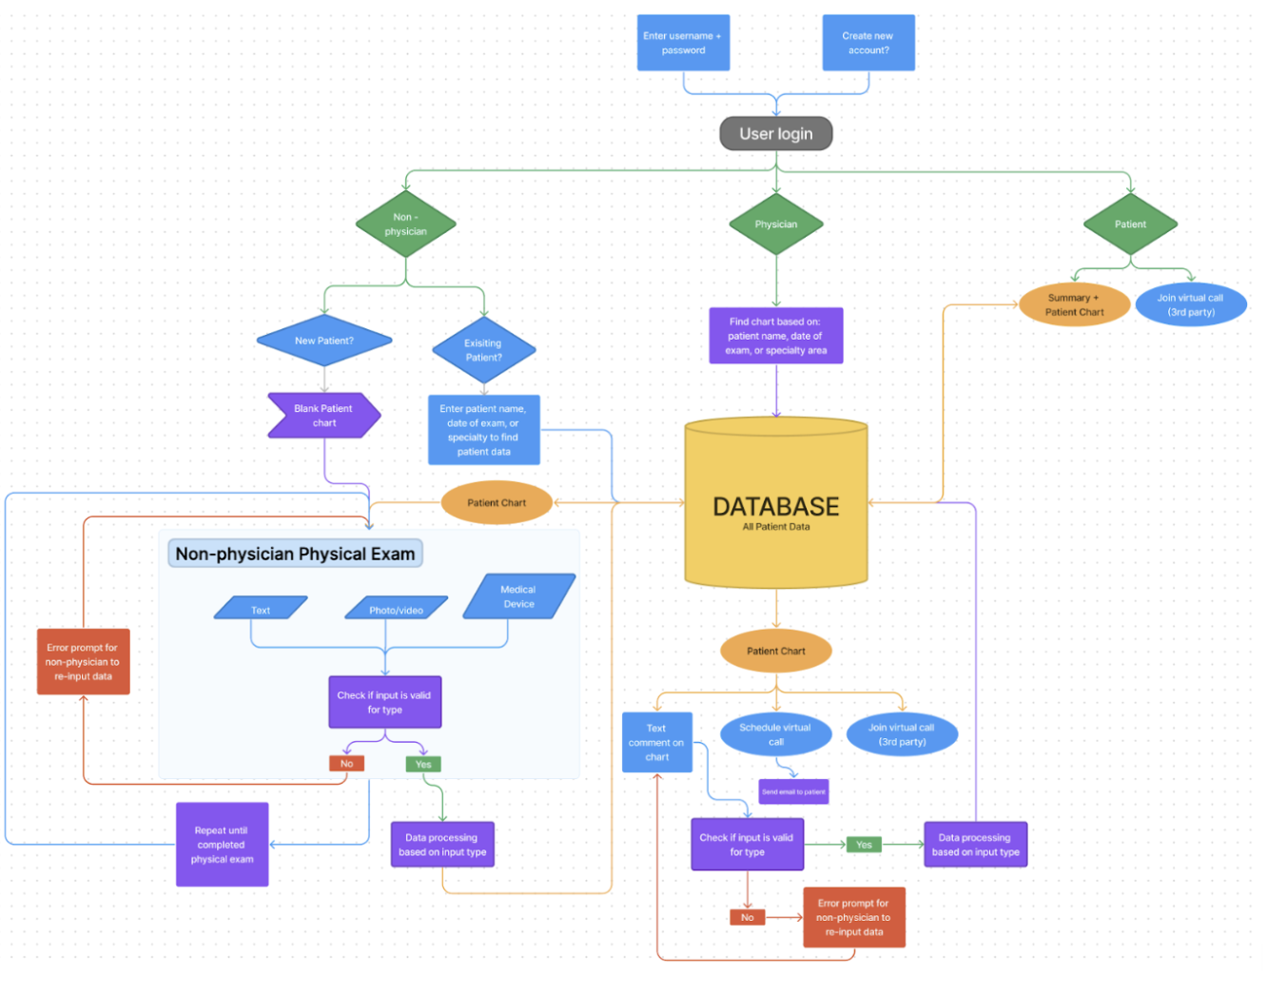

**Fig. B1.** Iteration 1 of our software flowchart.

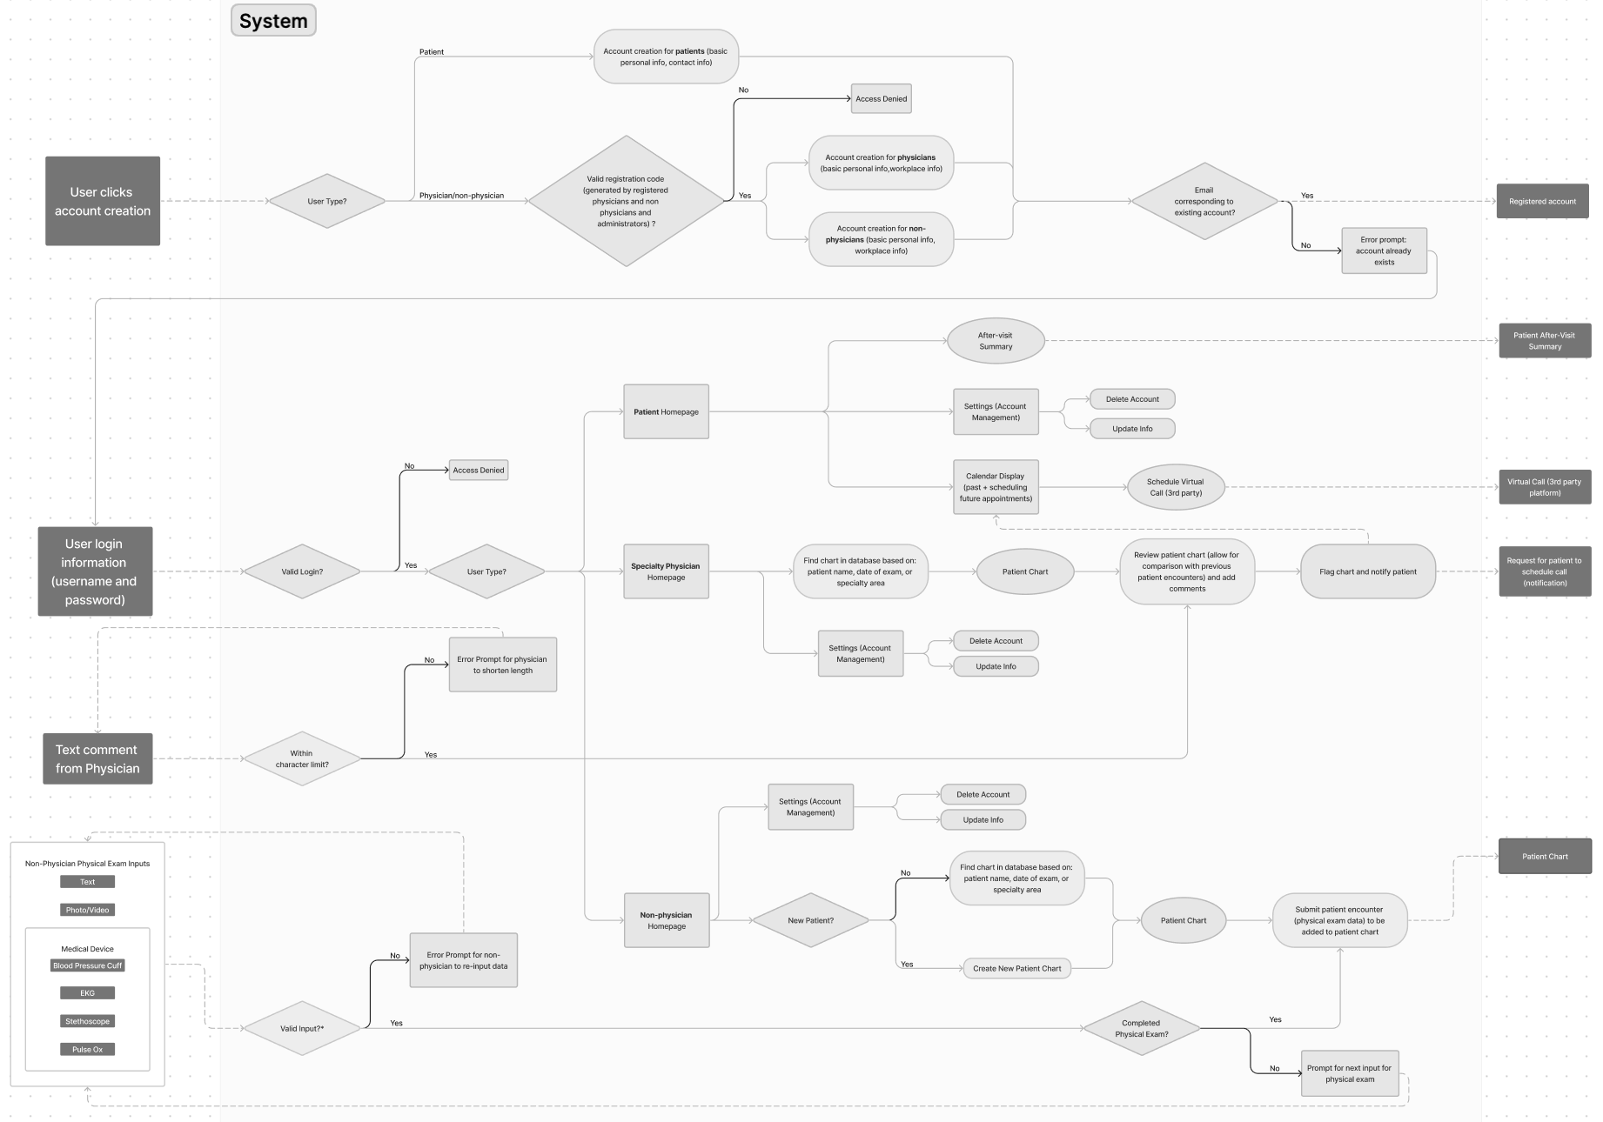**Fig. B2.** Iteration 2 of our software flowchart.

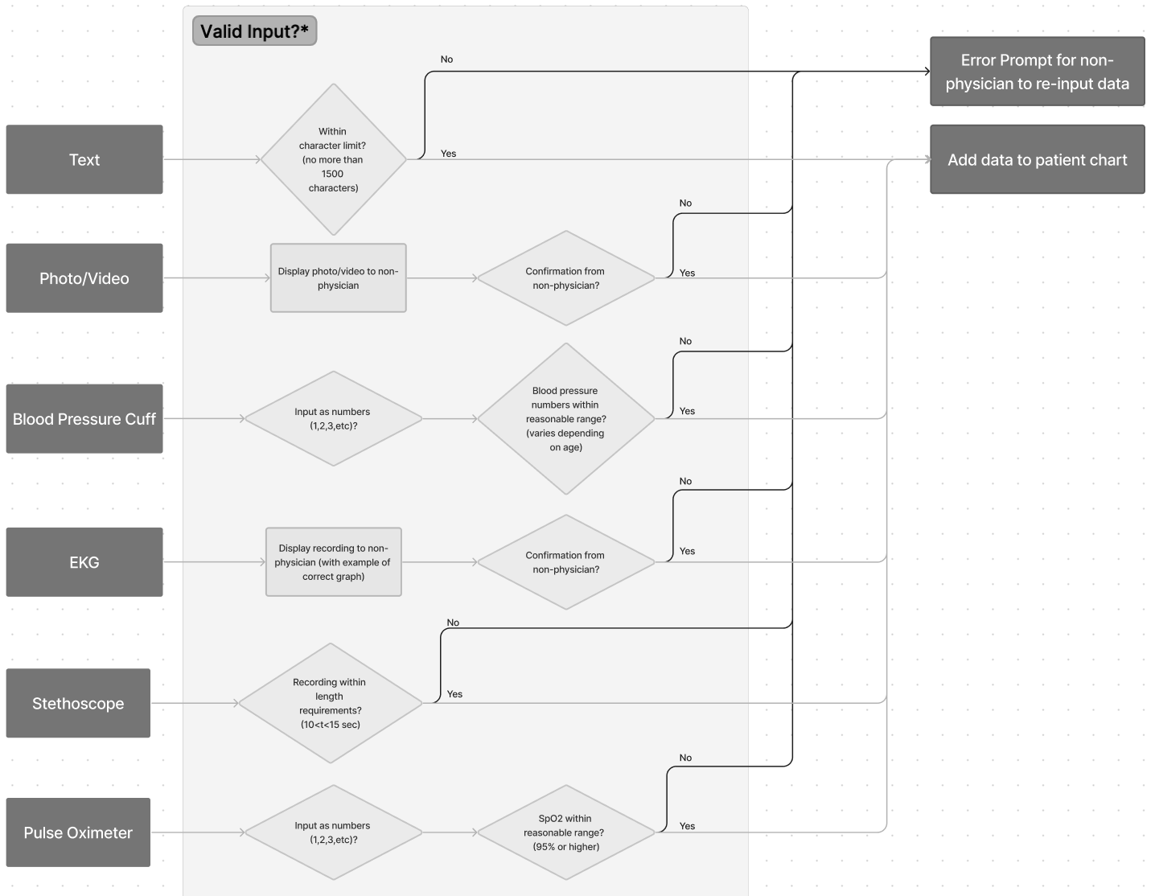

**Fig. B3.** Iteration 2 of our software flowchart, explanation of “valid input?” software component.

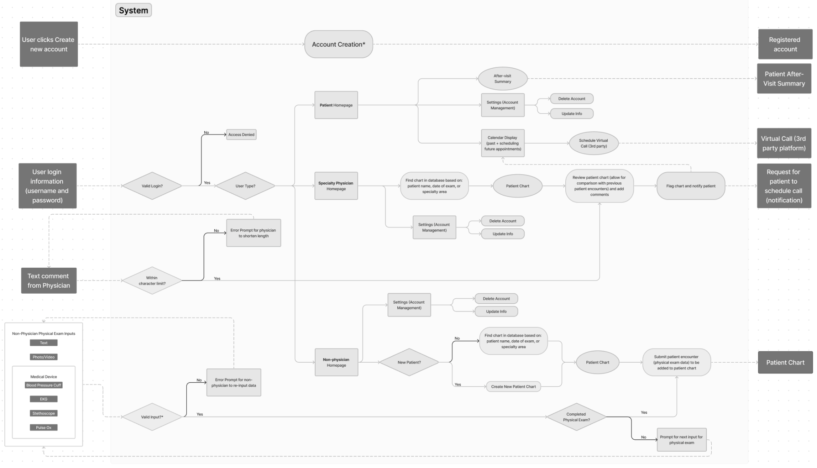

**Fig. B4.** Iteration 3 of our software flowchart, more generalized as to assist in our final function decomposition diagram development.

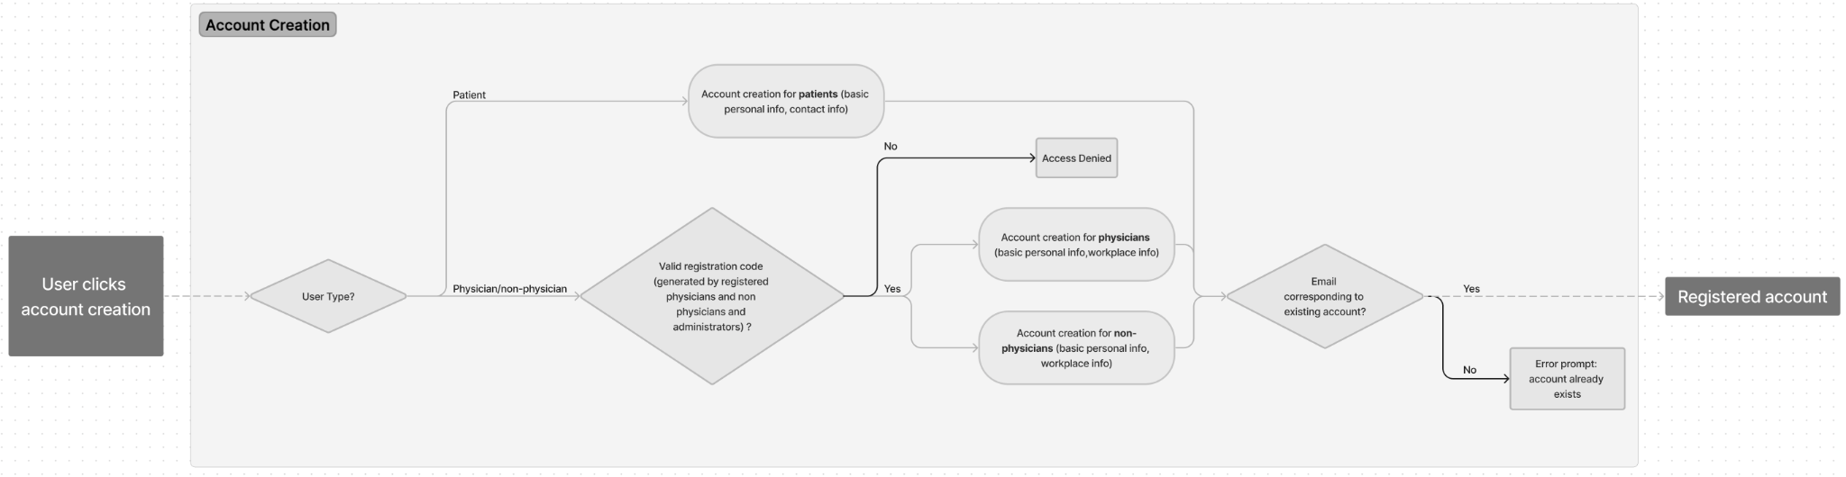

**Fig. B5.** Iteration 3 of our software flowchart, specifically focusing on account creation.

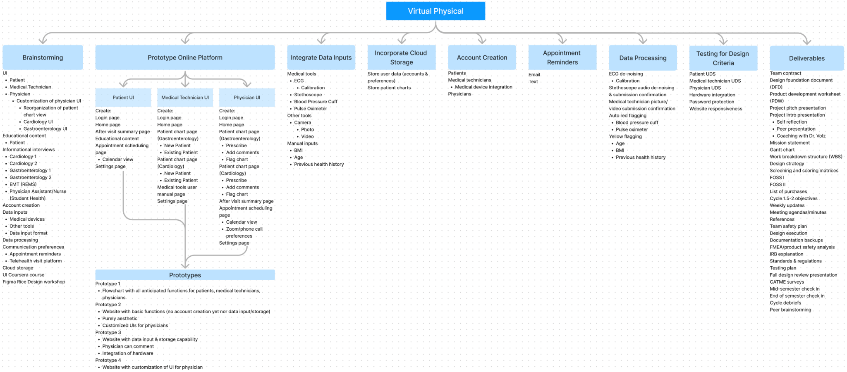

**Fig. B6.** Work Breakdown Structure (WBS) for Virtual Physical, demonstrating all general subcomponents of our brainstorming, prototyping, and deliverables.

# 

# **Appendix C**

Concept Generation and Screening Matrices

**Table C1**

Screening matrix on the patient calendar display for scheduling virtual appointments

| Criteria | Reference: MyChart by Epic's UI | Patient can choose specific doctor | Patient does NOT choose specific doctor (automatic assigning) | Patient can choose form of communication (ie Zoom, phone, etc) | Doctor chooses form of communication (ie Zoom, phone, etc) | Patient chooses appointment time at their convenience in time blocks | Doctor chooses appointment time at their convenience in time blocks |
| --- | --- | --- | --- | --- | --- | --- | --- |
| Integrates device data | 0 | 0 | 0 | + | + | 0 | 0 |
| Intuitive | 0 | + | + | - | + | + | - |
| Visually-pleasing | 0 | 0 | + | - | + | + | 0 |
| Straightforward | 0 | + | + | - | + | + | - |
| Net score | 0 | +3 | +4 | -3 | +5 | +4 | -3 |
| Continue? | n/a | no | yes | no | yes | yes | no |

**Table C2**

Screening matrix on the patient chart data display

| Criteria | Reference: MyChart by Epic's UI | Patients view the very detailed charts that the physicians access | Progress and reminders display given by the physician | After diagnosis, patients have access to educational resources through our platform on their diagnosis |
| --- | --- | --- | --- | --- |
| Integrates device data | 0 | + | 0 | - |
| Intuitive | 0 | - | + | - |
| Visually-pleasing | 0 | - | + | 0 |
| Straightforward | 0 | - | + | - |
| Net score | 0 | -2 | +3 | -3 |
| Continue? | n/a | yes | yes | no |